Transitional Hair Styles

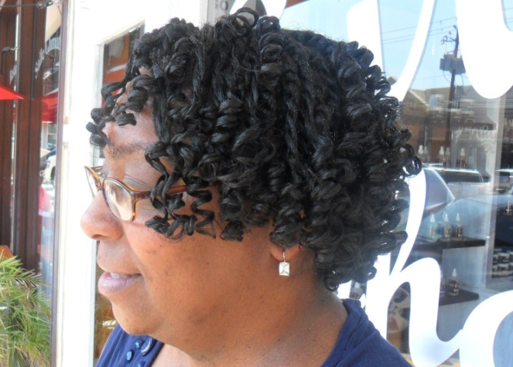
Transitions styles need not be a painful process. Once upon a time I would recommend flat ironing but these days we are seeing a lot of heat damaged’ clients. Meaning the heat from the flat iron is burning the hair and causing a permanent straightening effect. Leave the flat irons alone to avoid destroying the natural hair texture you are trying to cultivate. The style I did above is a transitional style. She has approximately 4 inches of new grow in her hair, so I twisted her hair and set it on rods. This style will last about 3 weeks. So if you are transitioning, the best way to do this is some kind of set whether its rod set, braid-outs, twist-outs.

